Tessella Project Number: 7567
Tessella plc 26 The Quadrant, Abingdon Science Park, Abingdon, Oxfordshire, OX14 3YS, UK
T: +44 (0)1235 555511 | F: +44 (0)1235 553301 | E: info@tessella.com | www.tessella.com

Client: STFC & ORNL
Mantid
PM report to Project Management Board
13th March 2013



Document Control
This document is under document control. All members of the distribution list will receive updated copies whenever alterations are made. All other copies are uncontrolled.

Contributors
Name | Role | Company
Nicholas Draper | Author | Tessella

Document Approval
Name | Role | Company

Distribution
Name | Role | Company
Project Management Board Members | Recipient | STFC & ORNL
Mantid Project Repository | Filing | STFC & ORNL

Revision History
Author | Issue | Date | Description
Nicholas Draper | V1.R1.M0 | 30-Sep-2013 | 1st version written

References
Document | Ref | Date | Details and Version
Project Specification | [PS] |  | https://github.com/mantidproject/documents/blob/master/Project%20Management/ProjectSpecification.doc?raw=true
Stakeholder Plan | [SP] |  | https://github.com/mantidproject/documents/blob/master/Project%20Management/StakeholderPlan.doc?raw=true
Risk Register | [RR] |  | https://github.com/mantidproject/documents/blob/master/Project%20Management/RiskRegister.xls

Table of Contents
1 Introduction 4
1.1 Purpose of this Document 4
1.2 Scope of this Document 4
1.3 Context of this Issue 4
2 Minutes of the previous meeting 4
3 Project Documentation 4
3.1 Stakeholder Plan: 4
3.2 Risk Register: 4
4 Project Status 4
4.1 Development Progress 4
5 Mantid Governance 5
6 Purpose of the Scientific Steering committee(s) 5
7 Discussion of commonalities between scientific strategies ISIS/SNS 6
8 Future Release Dates 7
9 Appendix A 8
9.1 Project Metrics 8
9.2 Ticket completion rate 9
9.3 Project Uptake 10

Introduction

Purpose of this Document
This report details the current state of the Mantid project and presents the agreed agenda for discussion. The project management board will use the information in this report as a basis for the meeting.

Scope of this Document
The scope of this document is limited to the Mantid project, both for progress up to the meeting of the Project management board, and plans for the future.

Context of this Issue
This is the ninth project management report to the Mantid project management board and will provide input to the meeting.

Minutes of the previous meeting
The minutes of the previous meeting are available here:
https://github.com/mantidproject/documents/blob/master/Project%20Management/PMB/Minutes/PMBMinutes30thNov12.docx?raw=true

Project Documentation
The project documentation is available through the links below. The Risk Register has been reviewed and updated. The other documents have not been changed since the last PMB meeting.

Stakeholder Plan:
https://github.com/mantidproject/documents/blob/master/Project%20Management/StakeholderPlan.doc?raw=true
Updates:
Not updated

Risk Register:
https://github.com/mantidproject/documents/blob/master/Project%20Management/RiskRegister.xls
Updates:
Not updated

Project Status

Development Progress
Since the last PMB meeting in November 2012 we have completed two development iterations and released new versions of Mantid on the following dates:
- v2.5 10th May 2013
- v2.5.3 31st May 2013
- v2.6 2nd August 2013
- v2.6.1 20th August 2013
Development continues at a good pace: see the project metrics in section 11.2.

Changes to supported Operating Systems

Mac OS X Snow Leopard
This version of the Mac operating system is starting to restrict our development, primarily as it relies on Python 2.6, rather than 2.7 like most of the other environments. We propose to move our lowest supported Mac OS X version up to Mountain Lion after Mantid Release 3.0. We will warn people in the Release 3.0 release notes.
This will not affect ORNL staff (as Mountain Lion is the minimum version at ORNL), but could affect users, and both users and staff at ISIS. However by that time the next release of Mac OS X Maverick will be available, so we will still be supporting two versions.
To Decide: Is this approved?

Referencing Mantid, DOIs and the approval of the Mantid Paper

Mantid Paper
The Mantid Paper is almost ready and the most recent draft will be circulated amoung all attendees before the meeting. As the PMB we must approve the paper before publication. At he

Digital Object Identifiers (DOIs)

Referencing Mantid

Mantid Governance model

Steering team meeting and develop meeting planning and approval

Meetings

Scientific Steering Committee
This is the meeting proposed in our March PMB, bringing a representative from each technique face to face to bring out medium to long term requirements for Mantid. Allowing for some time for the scientists to meet their colleagues, A technique specific meeting, followed by a larger general meeting to identify commonalities. The requirements from this meeting are to feed into the PMB for planning for the next years development.

Mantid Training
We now have 4 training courses (2 ½ days total) that cover an introduction to Mantid, Python, Using Python in Mantid and Extending Mantid using Python. These have been very popular at ISIS, and we suggest it would be worth running at ORNL for instrument scientists, possibly users and select members of the development team. The development team members would be present to learn to present the courses themselves later.

Developer Worksop
The Annual developer workshop is an invaluable opportunity to build team relationships and share knowledge while discussing development procedures, tools and considering the development tasks for the year ahead.

Project Management Board
We propose that we hold the next PMB in January to consider the requirements from the scientific steering committee.

Proposed Agenda
By combining the Scientific Steering Committee, the developers meeting, and optionally a series of Mantid training sessions we can get the most benefit out of the travel costs and time of the team. Aligning a Project Management Board Meeting after the Scientific Steering Committee meetings will allow the recommendations to be fed into the board’s plans efficiently.
PreWork
Mantid Training Preparation and handout printing.
SSC representatives gather requirements from their local groups
Week 1
Monday –Wednesday (13-15 Jan) Mantid Training (4 courses - 3 days)
Thursday-Friday (16-17 Jan) Scientific Steering committee (1 day arrival and meeting colleagues, 1 day group discussions and overall requirements meetings).
Week 2
Monday-Wednesday (20-22 Jan) Developer Workshop (3 days)
Wednesday morning (22 Jan) Project Management Board (1/2 Day)

To Decide: Is this a reasonable Agenda? Should we include the Mantid Training

Travel and hospitality arrangements
For previous meetings the facility hosting has offered to cover the travel of three developers to the developer workshop, and offered to provide food and drink during the developer meeting. The facilities not hosting have provided travel for a similar number of developers.

To Decide: If we are expanding the meeting to include the scientific steering committee and training courses we need to consider how the cost of travel, subsistence and catering should be covered. For both the development team and scientists.

Proposed attendees
Based on the proposed agenda above I would suggest the following people
Both Weeks:
- Nick Draper
- Owen Arnold
- Martyn Gigg
Scientific Steering Committee
- 5 scientists, One representative each from Diffraction, Reflectometry, Indirect Inelastic, Direct Inelastic, Small Angle. Muons will hold a meeting at ISIS earlier.
Develop Conference
- Gesner Passos
- Anders Markvardsen
- Peter Parker

Inviting collaborators and interested parties to the Developer Worksop
For the last developer workshop we invited some collaborators external to the project to attend (at their own cost). Ricardo Leal from the ILL attended and found it helpful for several reasons.
- He got to meet some of the people he had been working with in person
- He learned and appreciated our ways of working, and then fitted in better with ongoing developments
- He took the opportunity to get some direct help from the developers during breaks.
- He got to see in person the team atmosphere and professional approach of Mantid.
To Decide: Should we invite collaborators and external parties again?

Update on interest from other facilities, and existing collaborations

Future Release Dates
The planned release dates for the rest of this year would be:
- 3rd May 2013
- 2nd August 2013
- 1st November 2013
This does not include patch releases.

Appendix A

Project Metrics
SubProject | Files | Statements | %comments
Mantid Framework | 3,257 (3,454) | 449,127 (367,568) | 19.2 (20.1)
MantidPlot | 800 (766) | 122,313(115,710) | 16.4 (15.8)
VATES | 273 (239) | 14,182 (10,294) | 20.6 (22.5)
Total | 4,430 (4,459) | 585,622 (493,572)
The metrics are defined as follows:
Metric | Description
Files | The number of .h, .cpp and *.py files (not including third party libraries) included in the analysis.
Statements | The number of valid C++ statements, loops, conditional statements and pre processor directives are included.
% Comments | This is the percentage of the overall number of lines which are comment lines. I have not directly reported the number of lines in the file, but a good rule of thumb is that it is roughly twice the number of statements.
The values presented at the last PMB are shown in brackets.

Ticket completion rate
Development on Mantid is performed in three month iterations, each of which ends with an official release of the software. Longer pieces of work sometimes have to span a development iteration in which case that piece of work appears as completed only in the iterations when it becomes available to the users.
The patch releases (2.x.x) are very much smaller and are used to solve issues that become apparent after the main release or release urgent improvements that have recently been added.

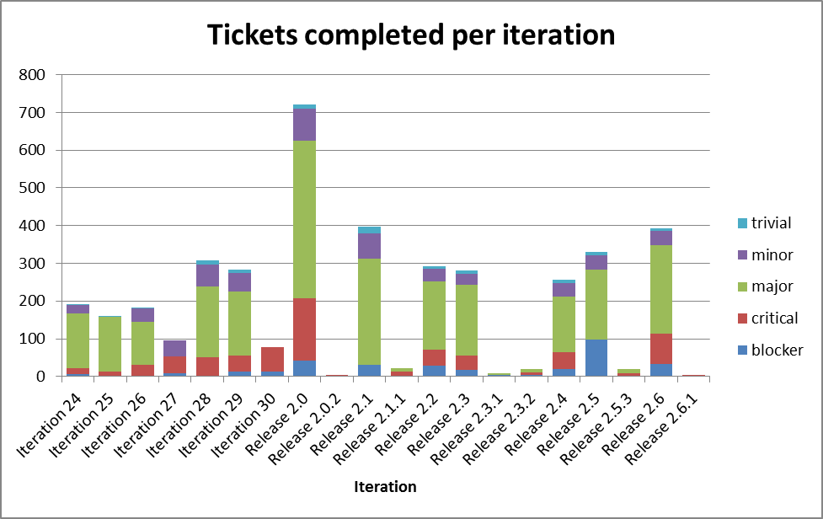

Project Uptake

Mailing List Subscriptions
Our software download site no longer requires people to register to a mailing list in order to download the installer packages. A simple analysis of the email domains shows that while the majority of the users are from ISIS, followed by ORNL and we have had some interest from other institutions and universities.
Summary
Date | 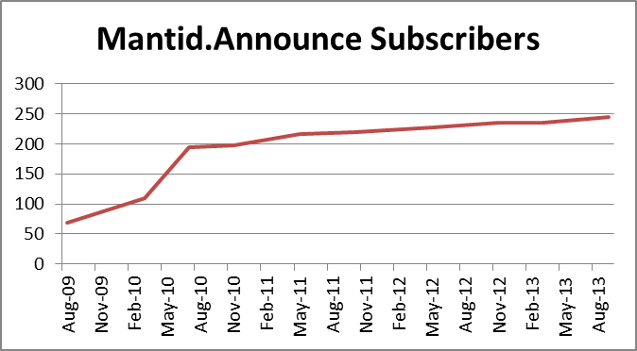  Users
Aug-09 | 68
Mar-10 | 109
Jul-10 | 195
Nov-10 | 197
May-11 | 217
Oct-11 | 219
May-12 | 228
Nov-12 | 235
Mar-13 | 235
Sep-13 | 245

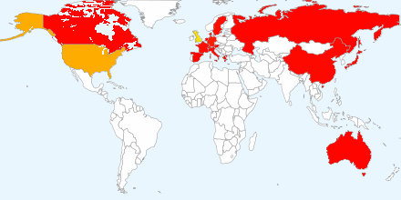
Current domain breakdown (2+)
Domain | count
stfc.ac.uk | 71
ornl.gov | 29
gmail.com | 22
helmholtz-berlin.de | 9
psi.ch | 3
swansea.ac.uk | 2
sheffield.ac.uk | 2
imperial.ac.uk | 2
caltech.edu | 2
esss.se | 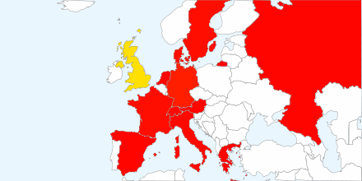  2
owlpic.com | 2
tudelft.nl | 2
ill.fr | 2
isc.cnr.it | 2
open.ac.uk | 2
physics.ox.ac.uk | 2
anl.gov | 2
bath.ac.uk | 2
uwstout.edu | 2
ansto.gov.au | 2
clemson.edu | 2
hmi.de | 2
ihep.ac.cn | 2
lanl.gov | 2

